

FACULTY OF ENGINEERING

DEPARTMENT OF COMPUTER SCIENCE

MASTER OF ARTIFICIAL INTELLIGENCE

|  |
| --- |
|  |
|  |
| Artificial neural networksPaper Florentijn Degroote  R0575914  [florentijn.degroote@student.kuleuven.be](mailto:florentijn.degroote@student.kuleuven.be)  2018-2019 |



# Assignment 1

## Perceptron

A perceptron is able to classify linearly separable data. Its limits are reached when trying to classify the points as shown in figure 2. The most basic case where the perceptron fails to classify the data is in the XOR problem. (Minsky, 2018)

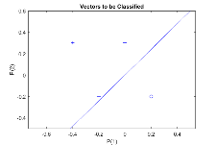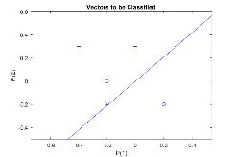

## MLP/noise/naïve bayes

Trainlm / traincgp is quickly done? Why? 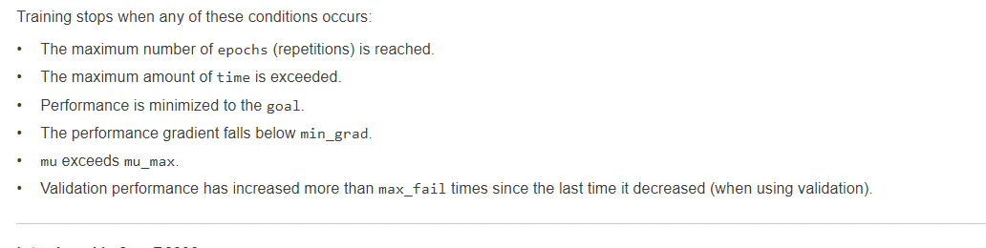

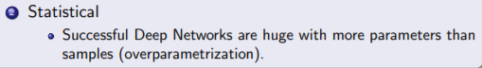

http://www-bcf.usc.edu/~lee715/slides/foundations_DL.pdf

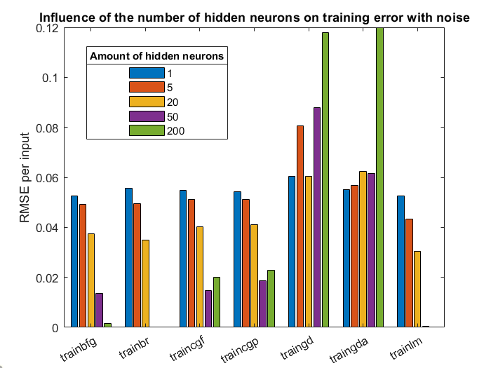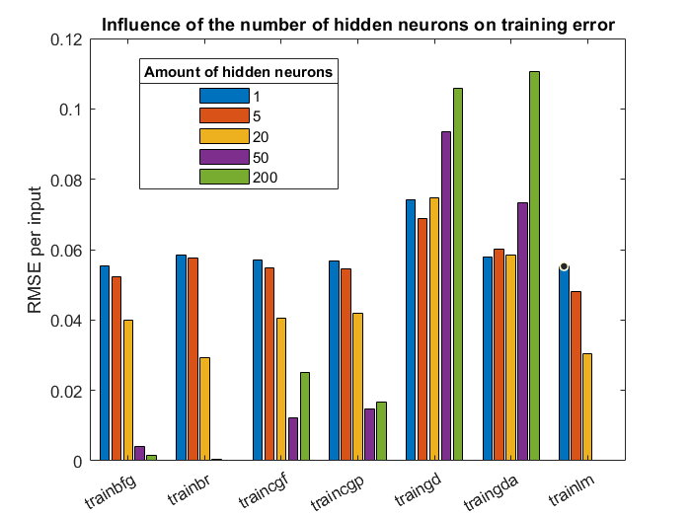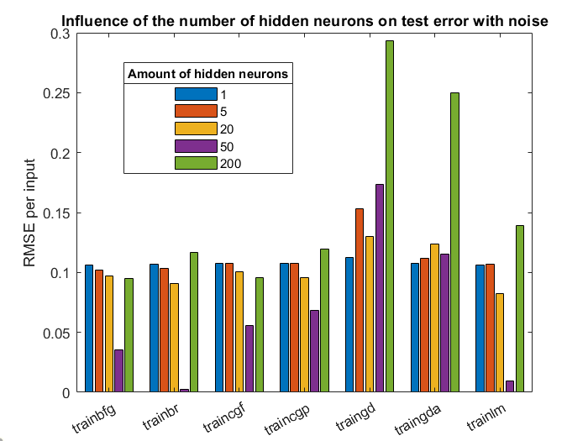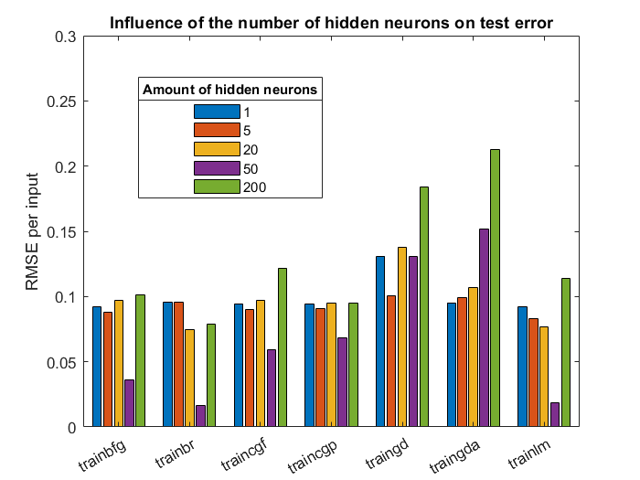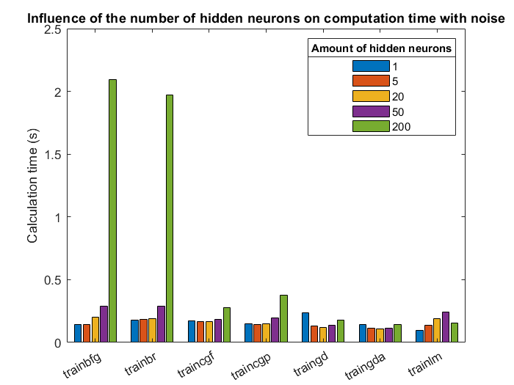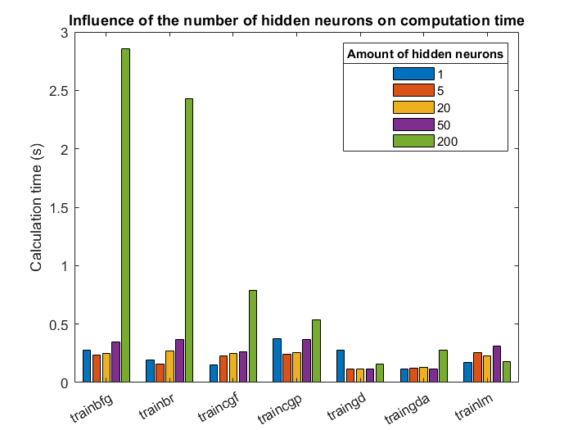

## Personal regression

Three sets:

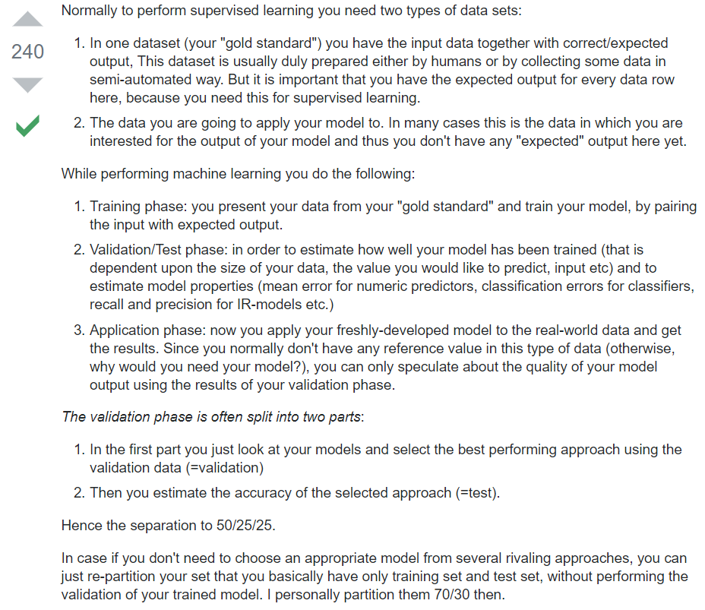

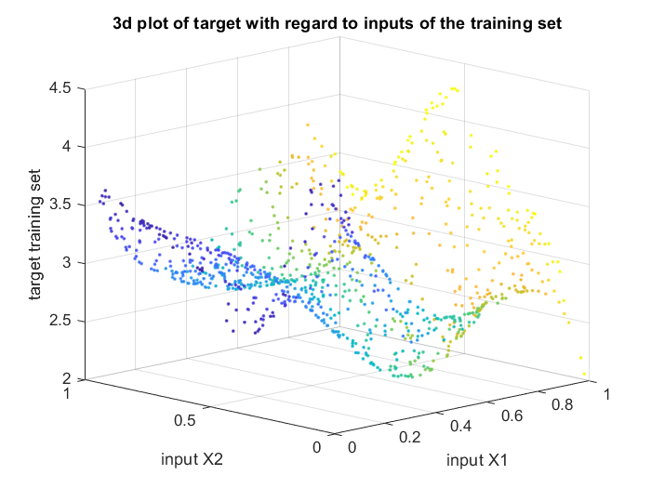

2. choosing learning algorithm;

Because trainlm and trainbr gave the best results in the previous tests, and because the setting is quite similar (though 1000 datapoints instead of 149 (=0.75*189)) and because the goal here is to minimize errors (focus is not really on computation time), we will check the results of these two.

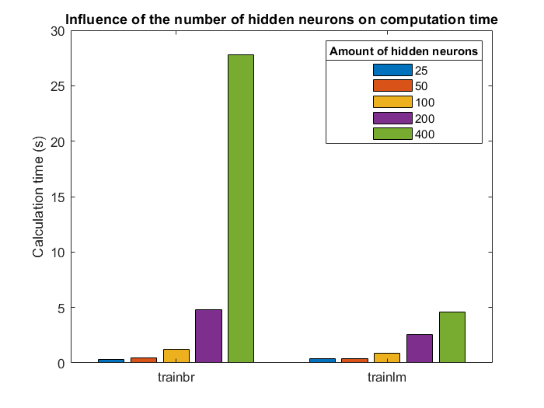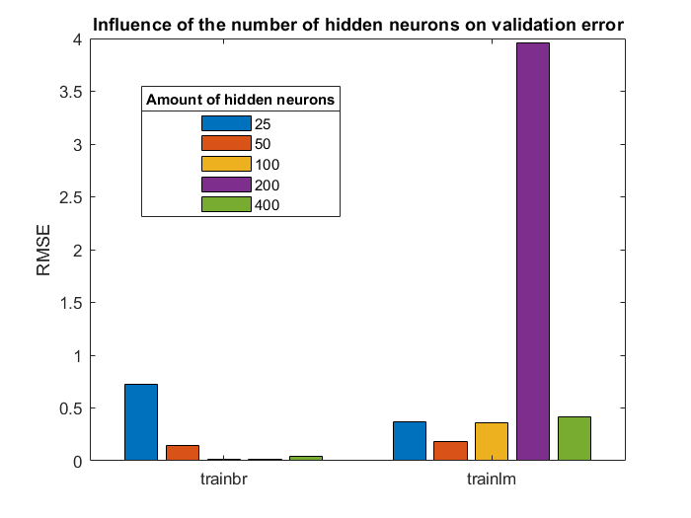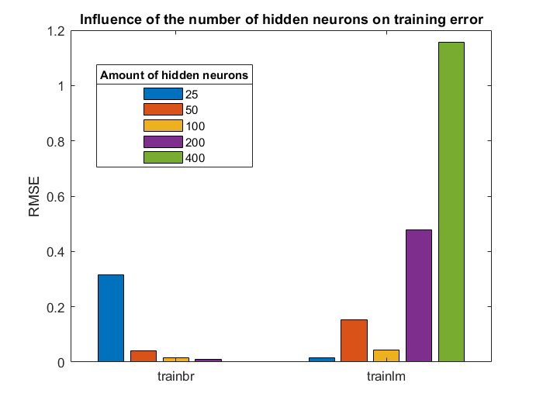

* Trainbr 100 neurons, 50 epochs



Lm is used in brainbr!

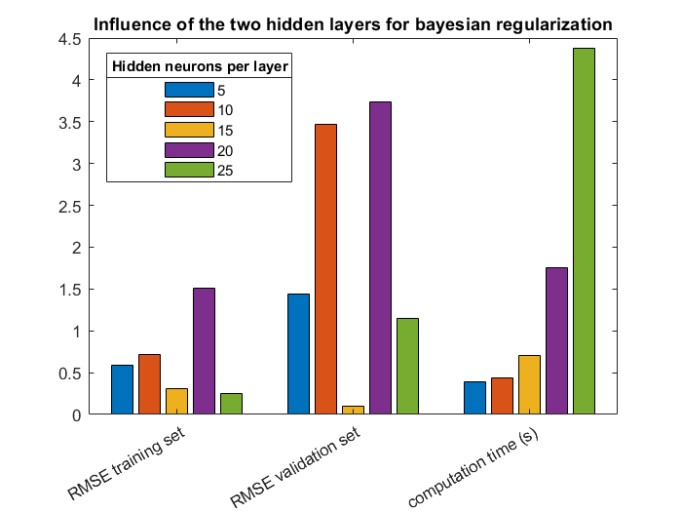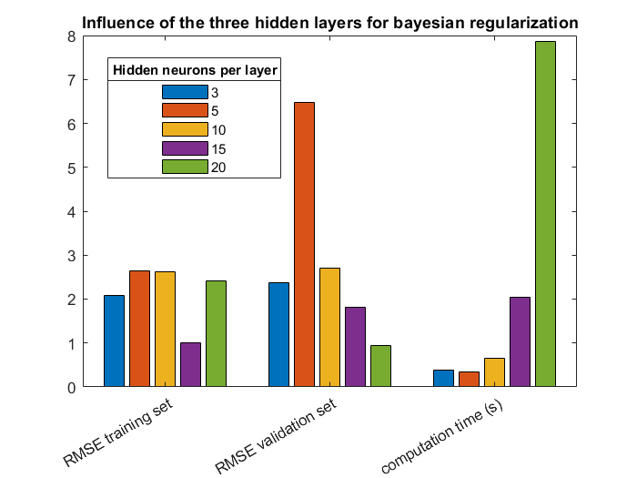

* One layer, 100 neurons seems best, trainbr, 50 epochs (activation function : transig for hidden and purelin for output)

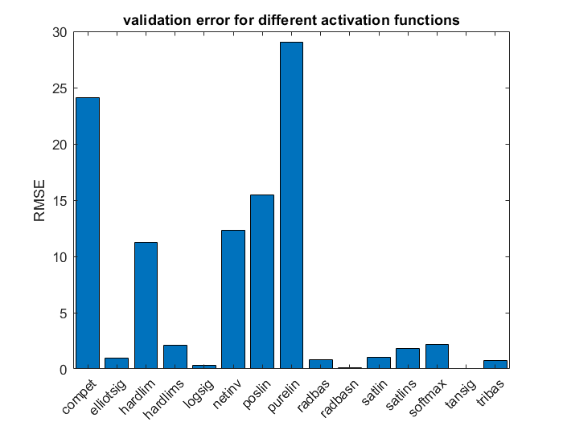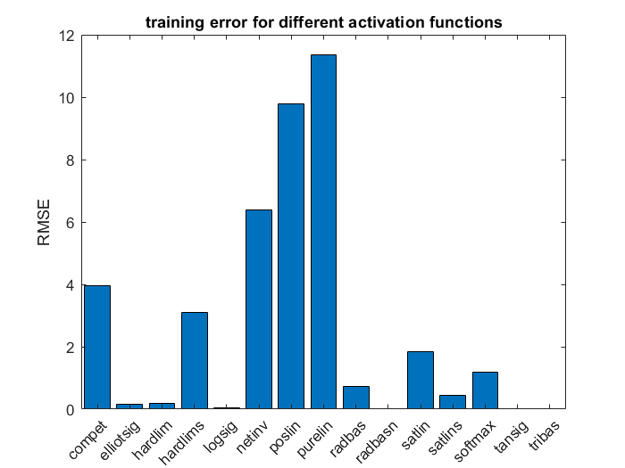

Tansig (is default): lowest combination!

0.0057 🡪 train

0.023 🡪 validation

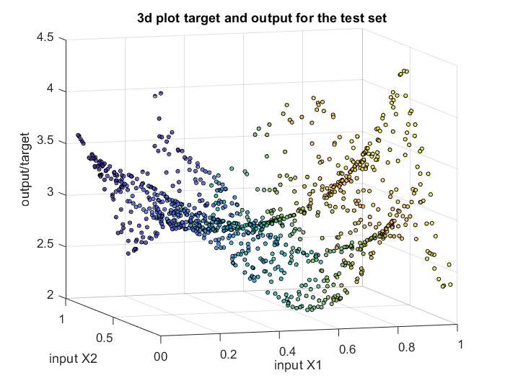 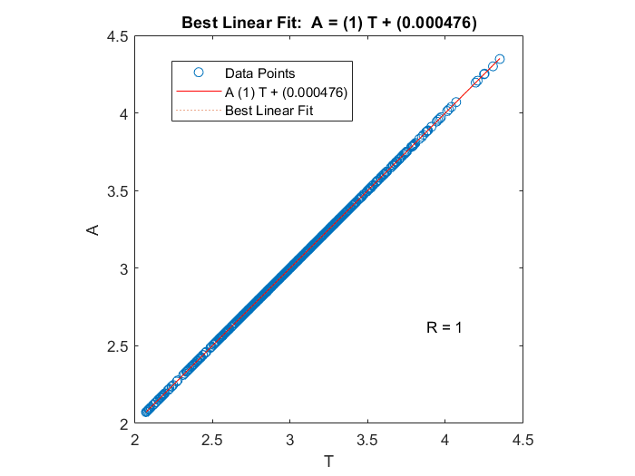

Black circles: output net; colours: target

3. Performance assessment;

1.4615e-04 SME for training set

0.0043 SME for test set

(0.0030 SME for validation)

Improvements; check activation functions for 2 and 3 layers?

# Bibliography

Minsky, Marvin, and Seymour A. Papert. *Perceptrons: An introduction to computational geometry*. MIT press, 2017.